Additional Exercises 15



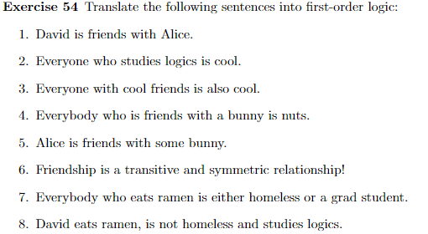

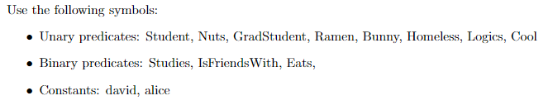

⋀⋁≡ㄱ≡ ∀ ∃

1. IsFriendsWith(david, alice)
2. ∀x∃y( (Studies(x,y) ⋀ Logics(y)) → Cool(x))
3. ∀x∀y( (IsFriendsWith(x,y) ⋀ Cool(y)) → Cool(x))
4. ∀x∃y( (Bunny(y) ⋀ IsFriendsWith(x, y)) → Nuts(x))
5. ∃x(Bunny(x) ⋀ IsFriendsWith(Alice, x))
6. ∀x∃y( (Eats(x) ⋀ Ramen(y)) → (Homeless(x) ⋁ GradStudent(x)) )
7. ∃y(Eats(david, y) ⋀ Ramen(y) ⋀ ㄱHomeless(david) ⋀ Logics(david))





∃y(P(y) ⋁ Q(y)) ⋀ ∀xR(x) ⋀ ∀x( ㄱR(x) ⋁ ㄱQ(x)) ⋀ ㄱ(∃xP(x))

∃y(P(y) ⋁ Q(y)) ⋀ ∀xR(x) ⋀ ∀x( ㄱR(x) ⋁ ㄱQ(x)) ⋀ (∀xㄱP(x))

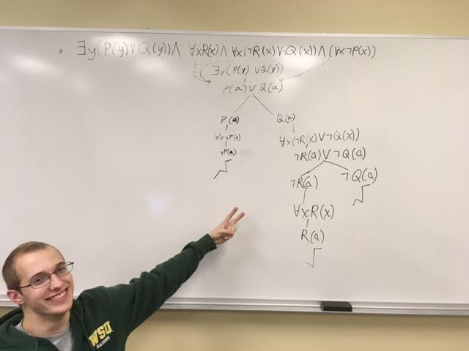



∃y(P(y) ⋀ ㄱS(y)) ⋀ ∀y(ㄱP(y) ⋁ Q(y)) ⋀ ∀y(ㄱQ(y) ⋁ (R(y) ⋀ S(y))) ⋀ ㄱ(∃x(P(x) ⋀ R(x)))

∃y(P(y) ⋀ ㄱS(y)) ⋀ ∀y(ㄱP(y) ⋁ Q(y)) ⋀ ∀y(ㄱQ(y) ⋁ (R(y) ⋀ S(y))) ⋀ (∀x(ㄱP(x) ⋁ ㄱR(x)))

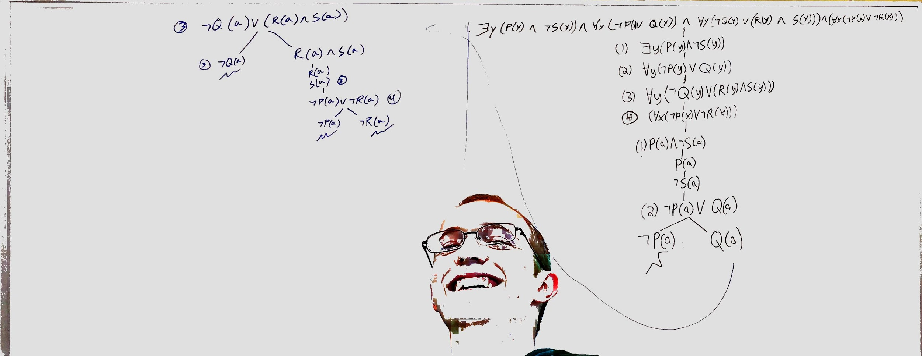

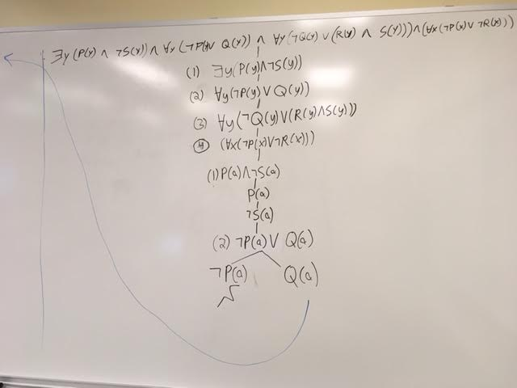[Sign out](https://accounts.google.com/Logout?service=wise&continue=https://docs.google.com)

